

OOAD PROJECT
HOTEL ROOM BOOKING SYSTEM
FACULTY: DR SOHAIL IMRAN

C Id:116251

S.NO | S.NAME | S.ID
1 | SHAYAN AKRAM | 14958

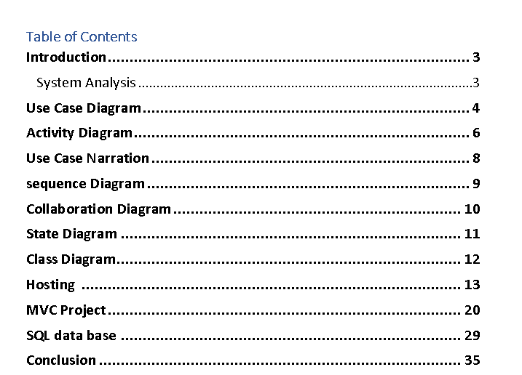

- INTRODUCTION:
The introduction section provides a background on the significance of a Hotel Management System and outlines the objectives of the project. It emphasizes the need for an organized, scalable, and user-friendly system to enhance the overall efficiency of hotel operations.
- System Requirements:
This section details the functional and non-functional requirements of the Hotel Management System. It includes an exhaustive analysis of user needs, system constraints, and external interfaces to ensure a comprehensive understanding of the project scope.
- Use Case Analysis:
The use case analysis section presents a detailed exploration of various use cases, identifying the interactions between system actors and the proposed functionalities. Use case diagrams, scenarios, and descriptions are provided to offer a clear understanding of the system's intended behavior.
- Class Diagrams:
The class diagrams section focuses on the identification of key classes, their attributes, and relationships. This involves modeling the various entities within the system, such as customers, rooms, staff, and administrative elements. The class diagrams serve as a foundation for the subsequent design and implementation phases.
- Sequence Diagrams:
Sequence diagrams illustrate the dynamic aspects of the Hotel Management System by depicting the sequence of interactions between system components over time. This section provides insights into how different entities collaborate to accomplish specific tasks and processes.
- State Diagrams:
State diagrams capture the different states and transitions that entities within the system undergo. This section helps in understanding the lifecycle of key objects and entities, contributing to a more comprehensive analysis of system behavior.
- Activity Diagrams:
Activity diagrams showcase the workflow and operational processes within the Hotel Management System. This section provides a visual representation of how different activities are performed and how they interconnect, aiding in the identification of potential bottlenecks and optimization opportunities.
Use Case Diagram

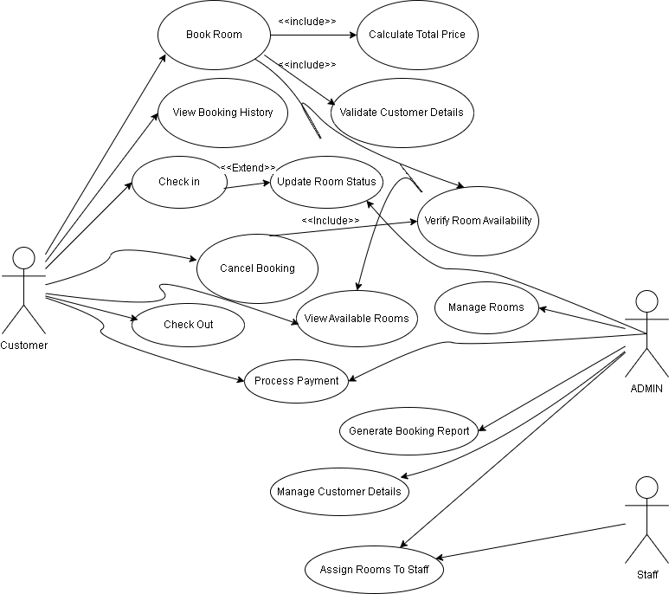
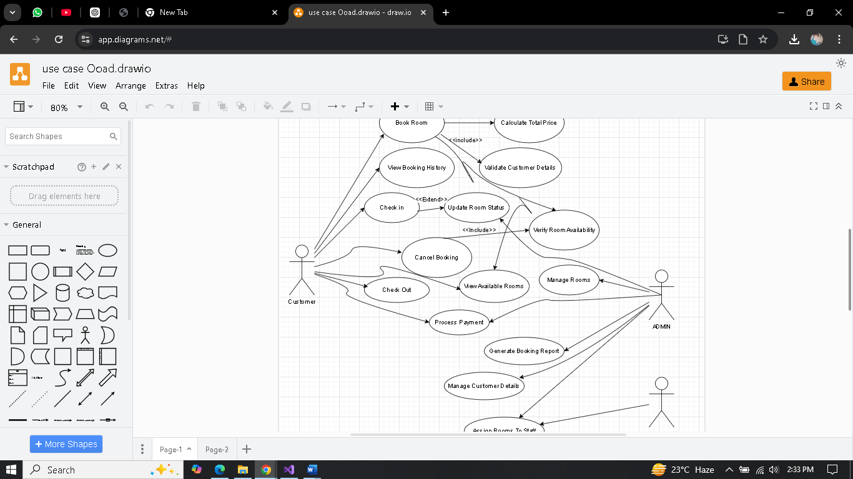
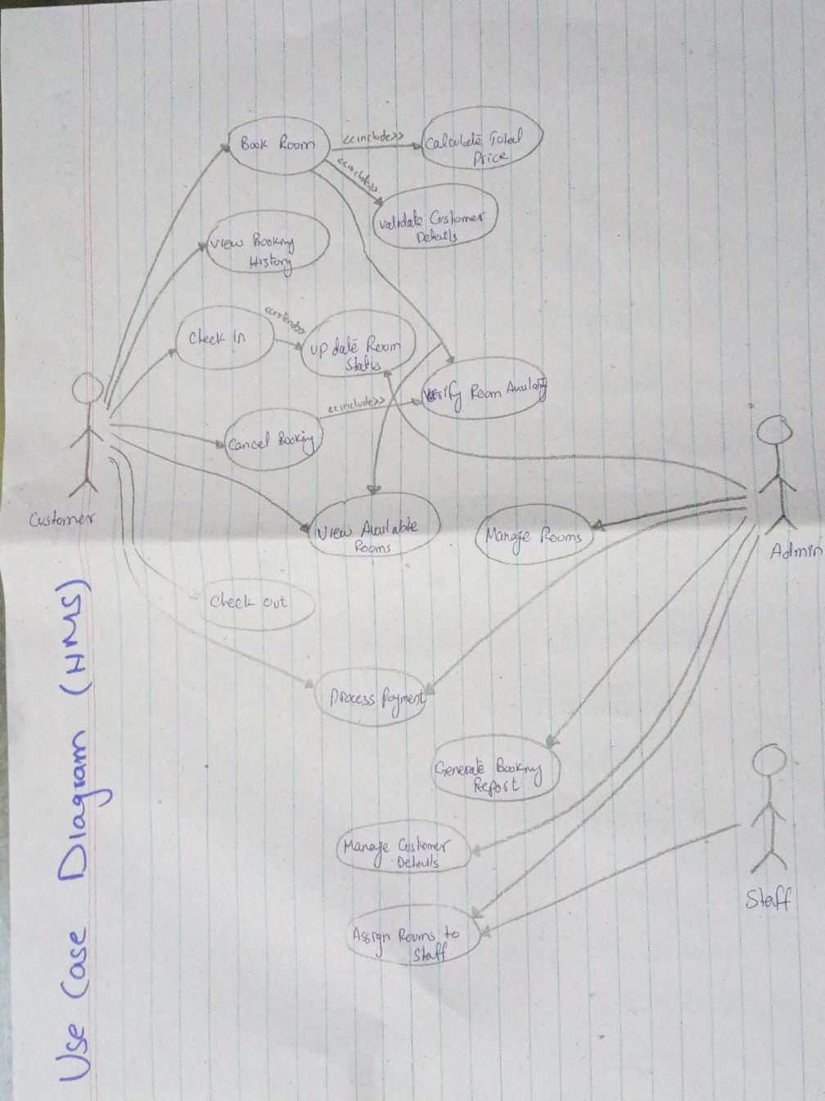
ACTIVITY DIAGRAM
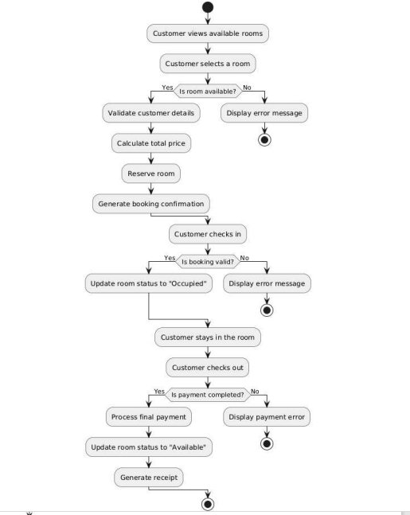

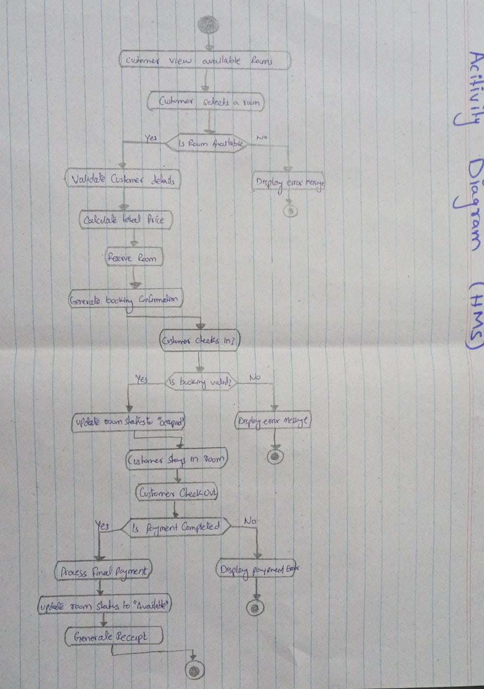
Use Case Narration
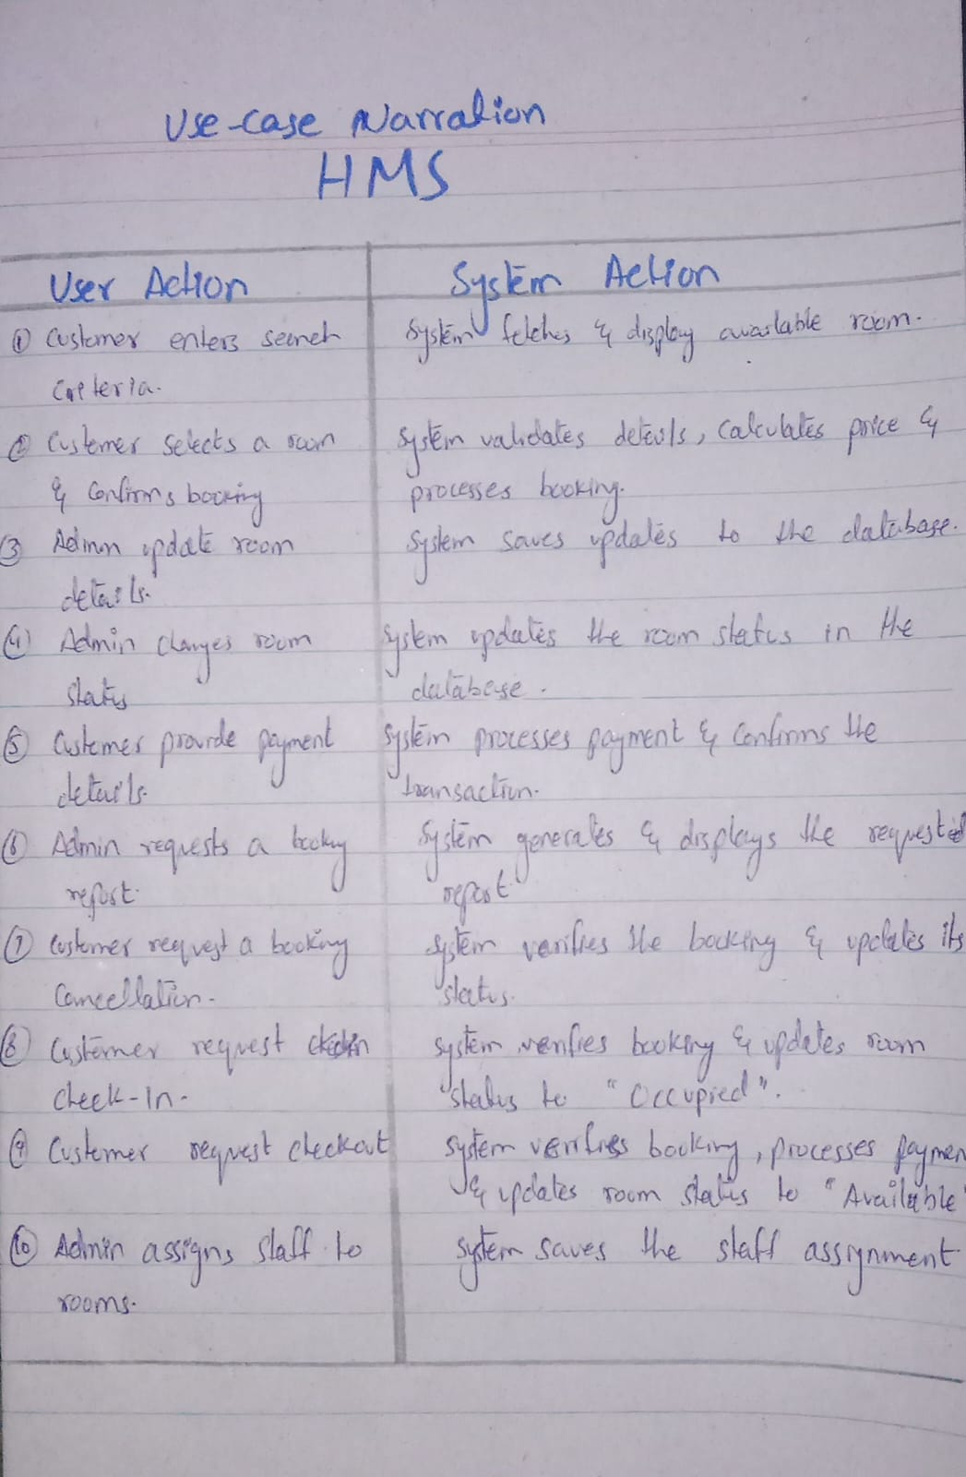
Sequence Diagram
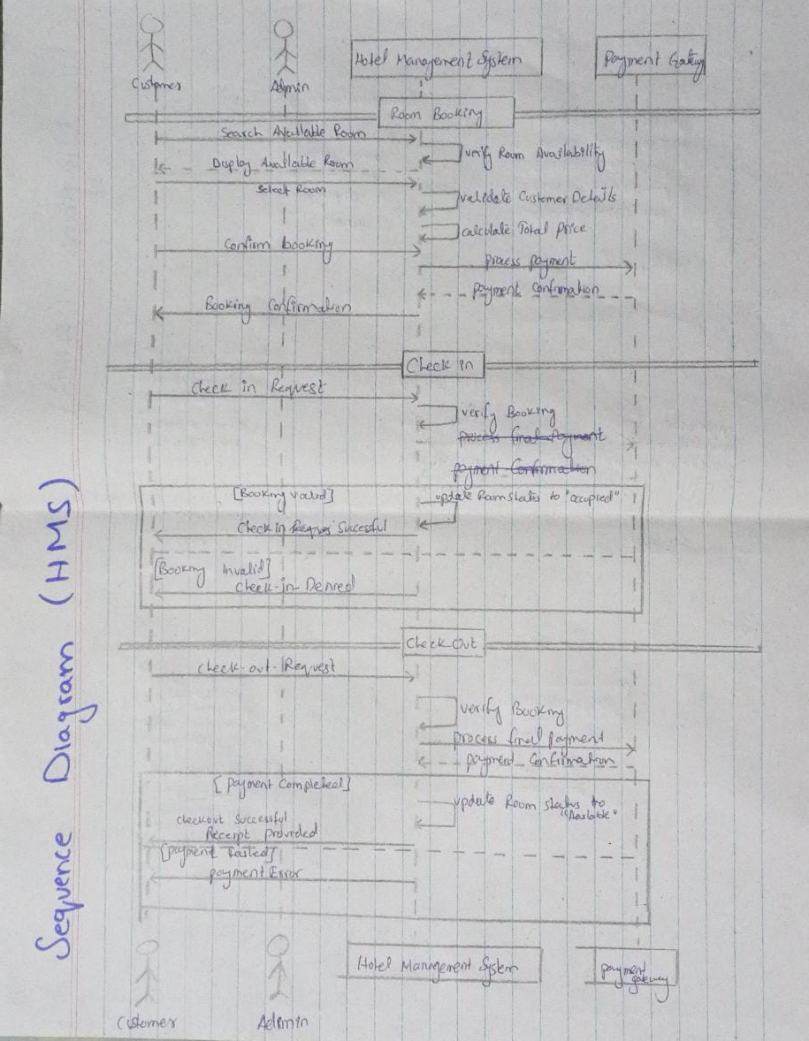
Collaboration Diagram
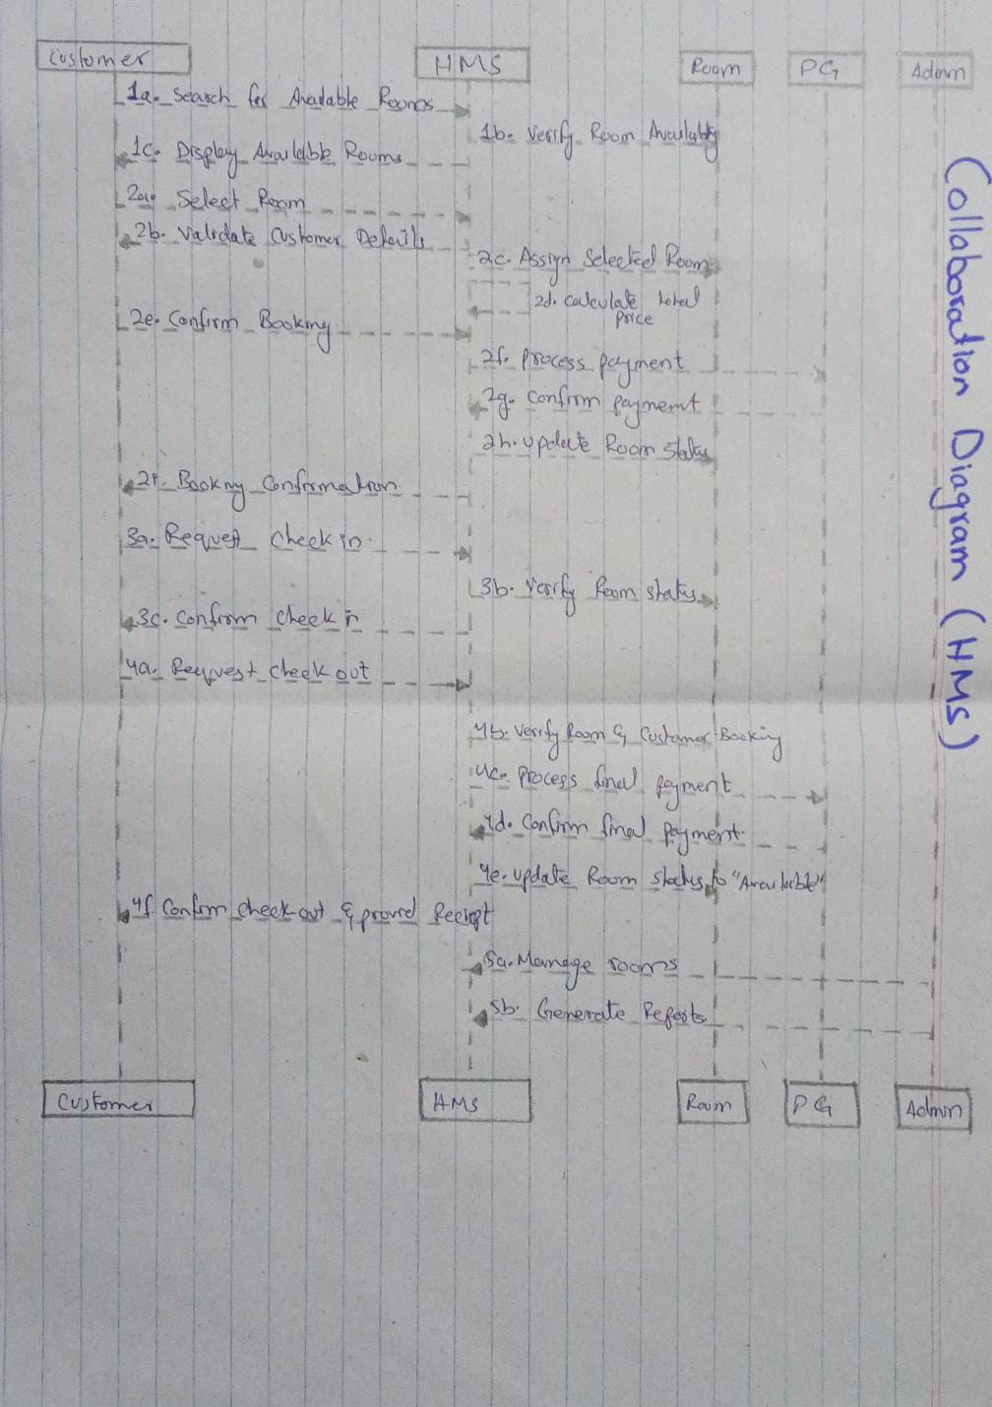
State Chart Diagram
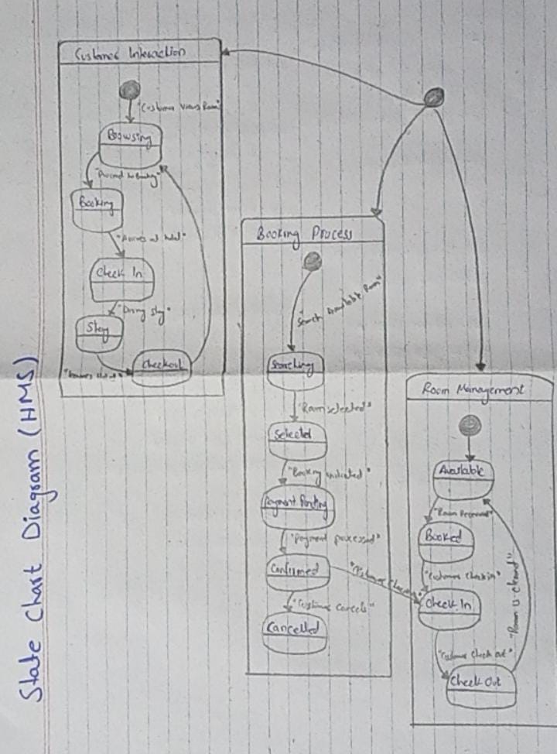
Class Diagram
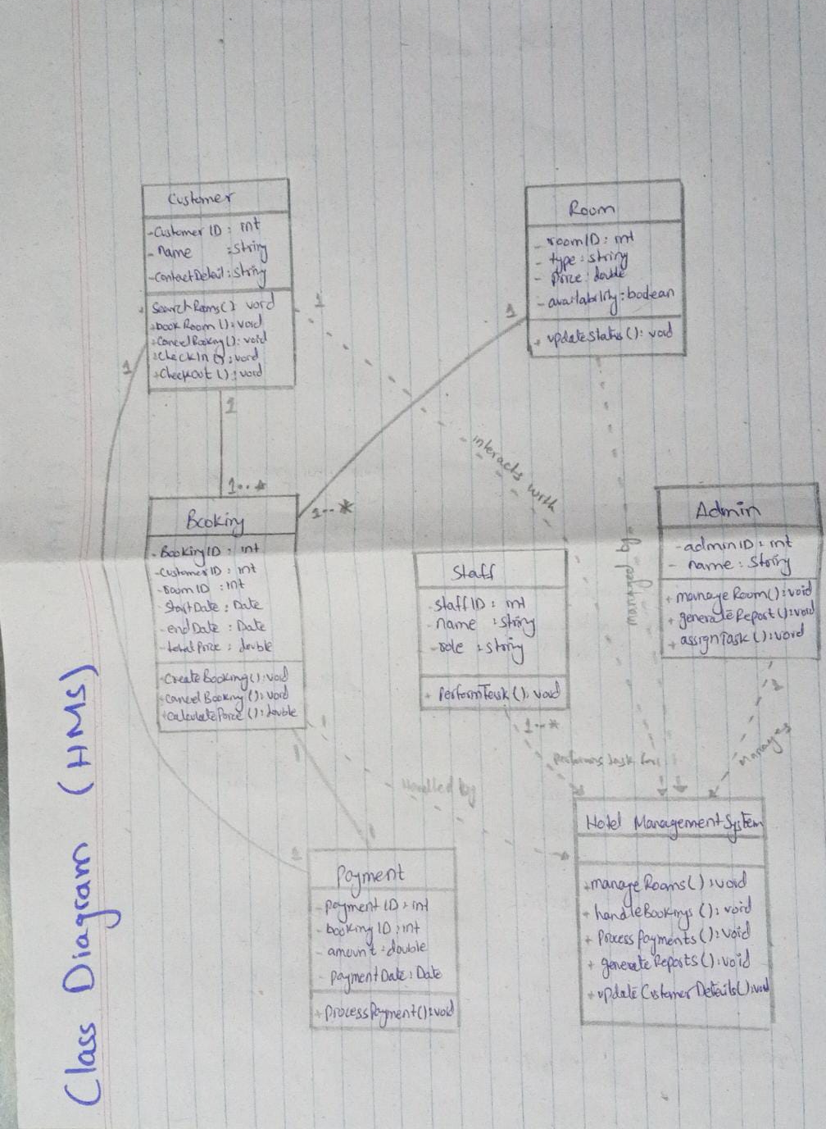
Hosting
SOMEE LINK:
Live Link: http://RoomBooking.somee.com
1. Sign Up and Log In
- Visit [Somee.com](https://somee.com/) and create an account. Once registered, log in to your dashboard.
2. Set Up Free Hosting Plan
Once logged in, go to "My Hosting" and choose "Add Hosting".
Somee offers a free hosting plan that allows you to deploy websites. When setting up, assign your hosting plan a name, which is also used as part of the URL for your website (e.g., yourproject.somee.com).
After setting it up, Somee provides details like FTP credentials and domain information.
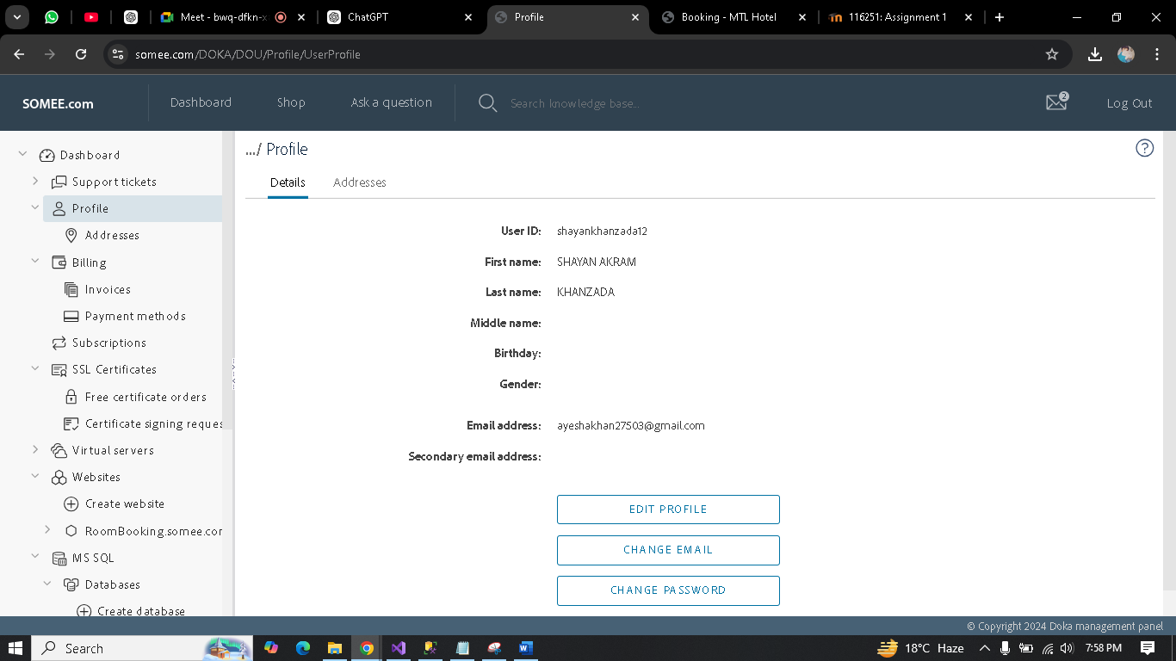

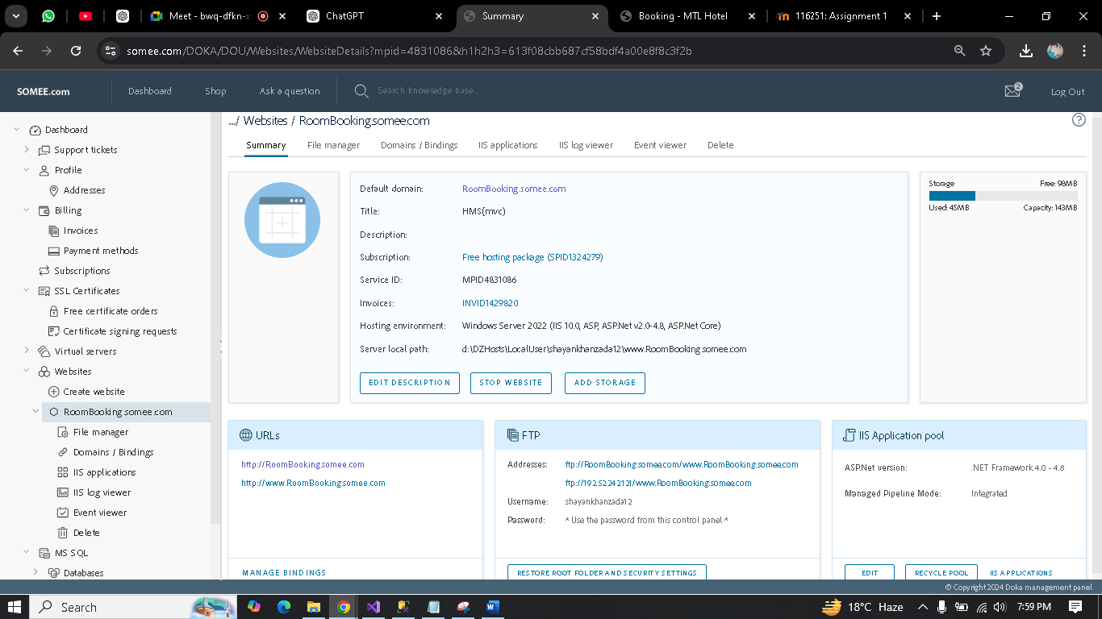

3. Configure SQL Database
- If your ASP.NET application interacts with a SQL database, you will need to create one in the Somee.com dashboard. Navigate to "Databases", click "Create Database", and fill in the necessary details (name, login credentials).
- The system will generate a connection string with your database information (server name, database name, username, and password). Save these details, as they will be required later when updating your ASP.NET application’s connection string.
Steps to Generate a Database Script in SSMS:
- Open SSMS and connect to your database.
- Right-click the database in Object Explorer.
- Select Tasks → Generate Scripts.
- Choose specific objects (tables, procedures, etc.) or the entire database.
- Configure advanced options (e.g., Drop and Create).
- Review and generate the script.
- Save or copy the script for use in other environments.

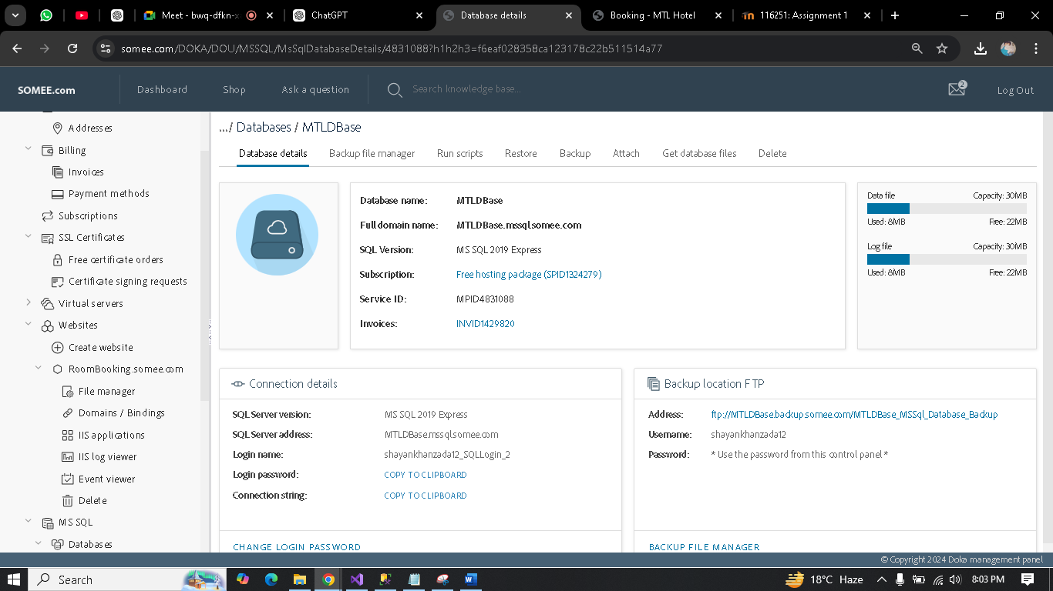
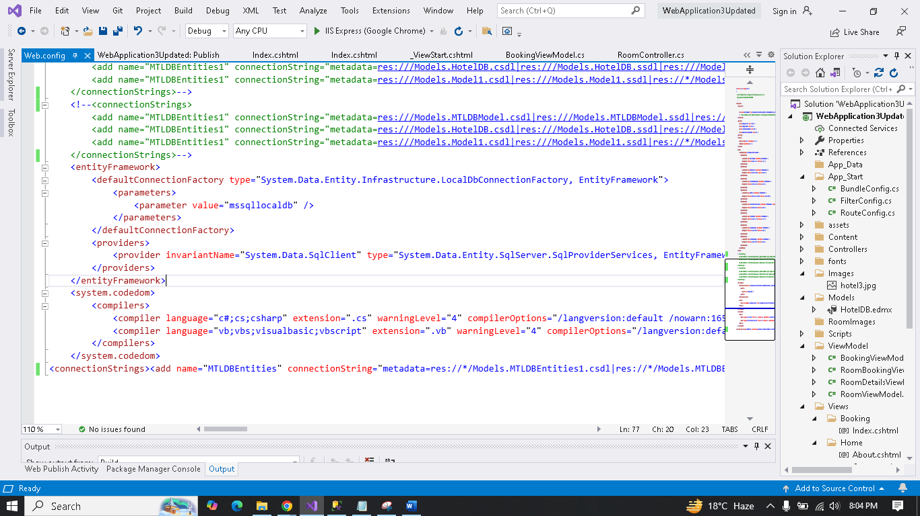
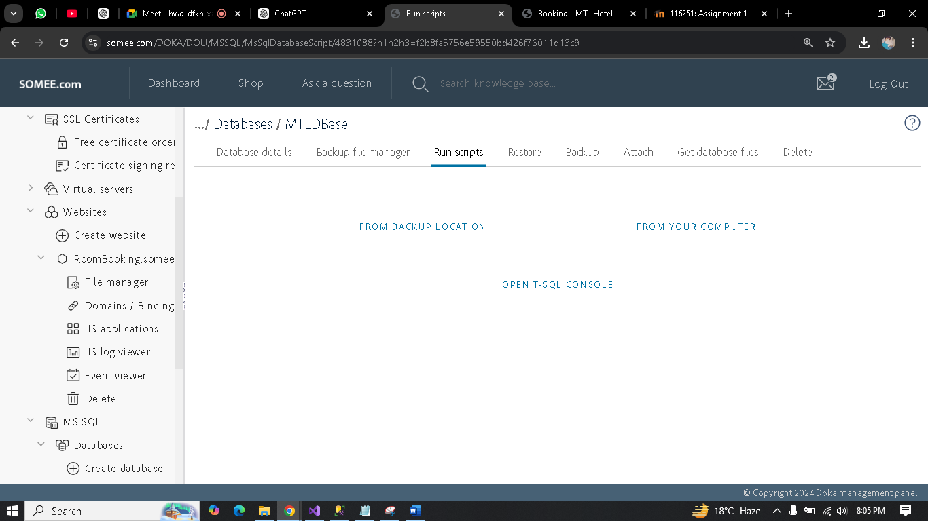

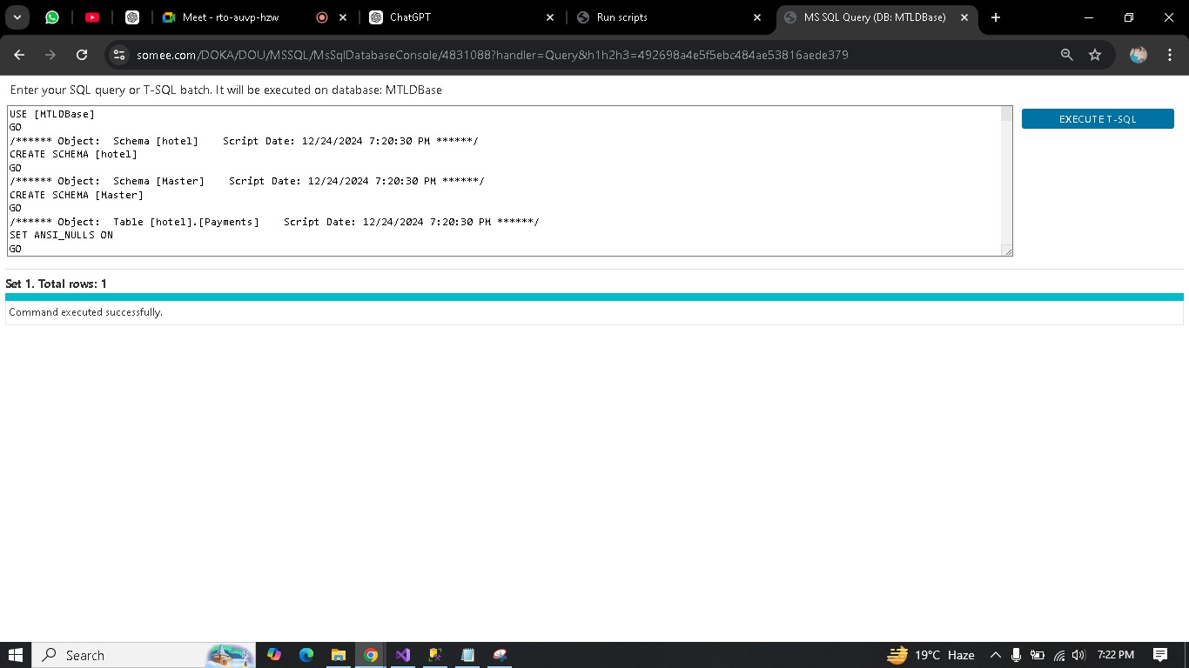

4. Prepare Your ASP.NET Project for Deployment
- Open Visual Studio and load your ASP.NET project. Before deploying, you need to publish the project:
1. Click Build from the top menu, then select Publish.
2. Choose "Folder" as the target method. This option allows you to generate your project’s files into a folder structure on your local machine.
3. Specify a local folder path where the files will be saved.
4. Click Publish, and Visual Studio will compile the project into deployable files in the specified folder (this will include .aspx files, .dll libraries, etc.).

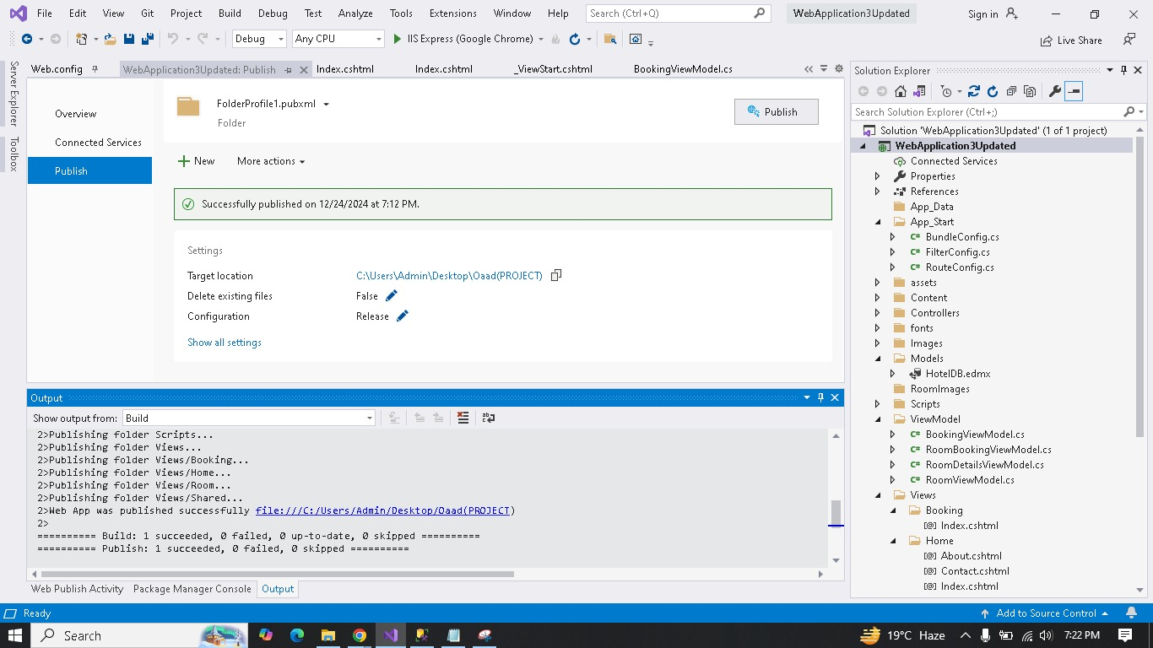

5: FileManager
- Log In: Access your Somee.com account and go to your hosting dashboard.
- File Manager: Open the File Manager and navigate to the Folder (OOADProjectLive) to the directory.
- Upload: Upload your zipped ASP.NET project on file manager.
- Unzip: Select the zip file and use the "Extract" option to unpack it.
- Verify: Check the extracted files, ensuring everything is in place.
- Delete Zip: Optionally, delete the zip file for security and space.

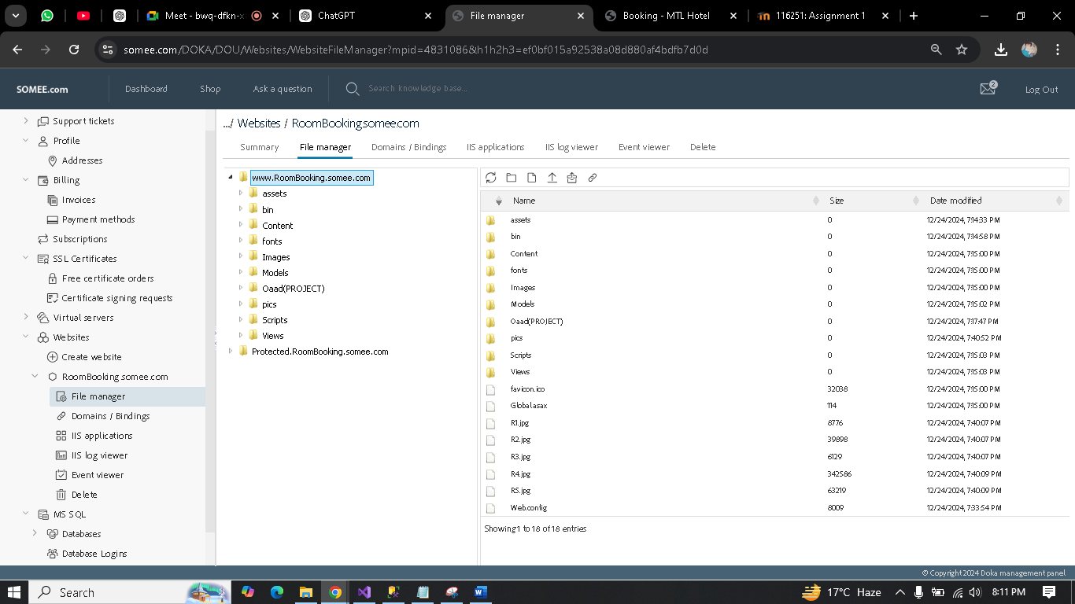
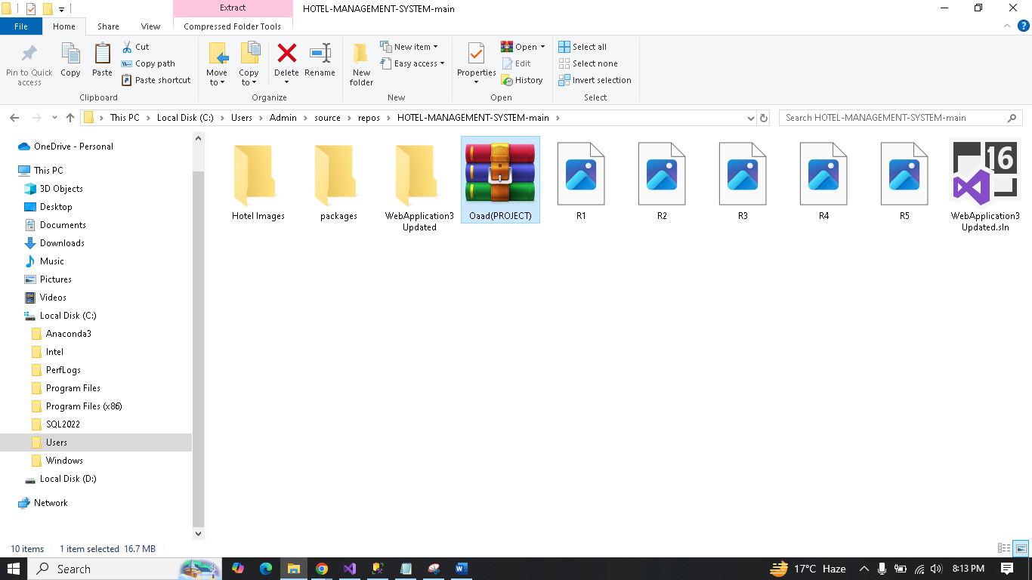

6. Test Your Website
- After uploading, access your website through the domain Somee.com provided (e.g., yourproject.somee.com). http://busbooking.somee.com/
- Test every functionality, including database operations, to ensure everything works as expected.
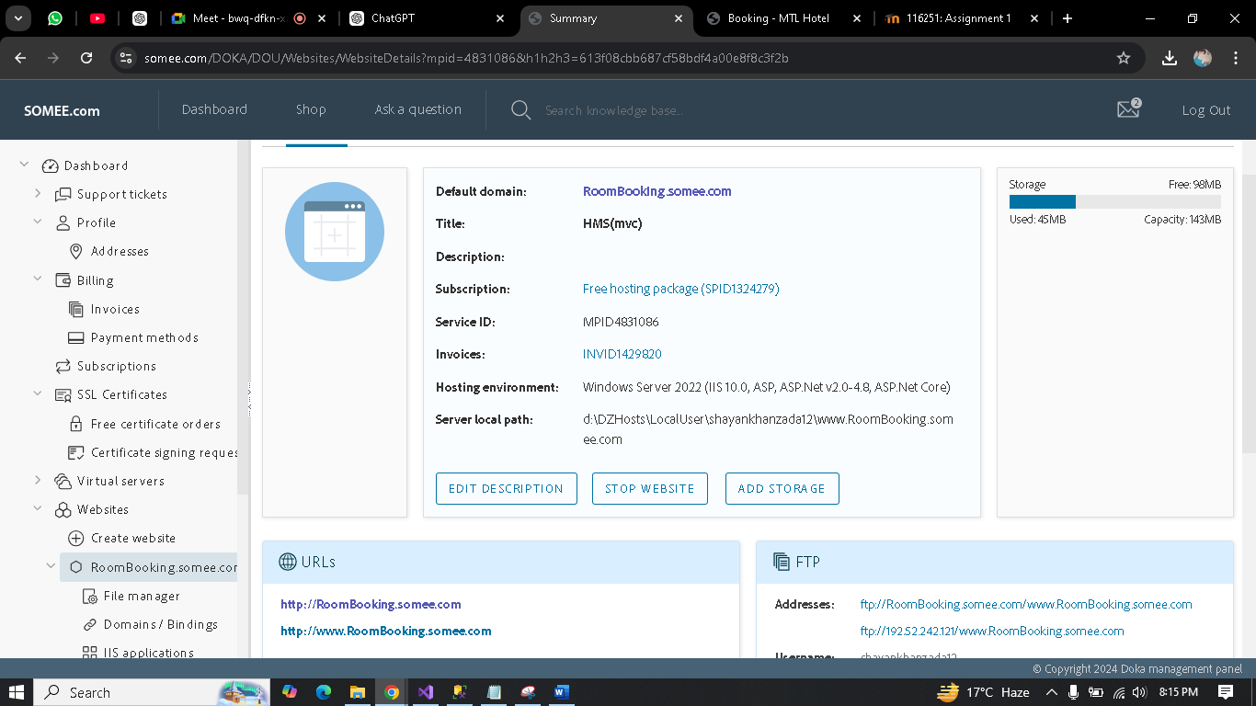

MVC (PROJECT)
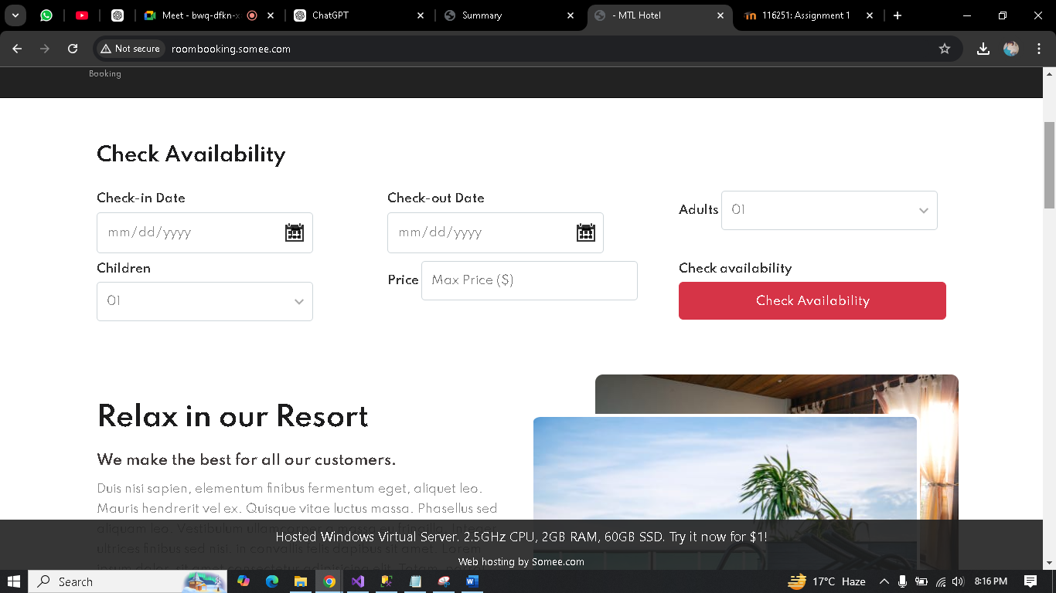
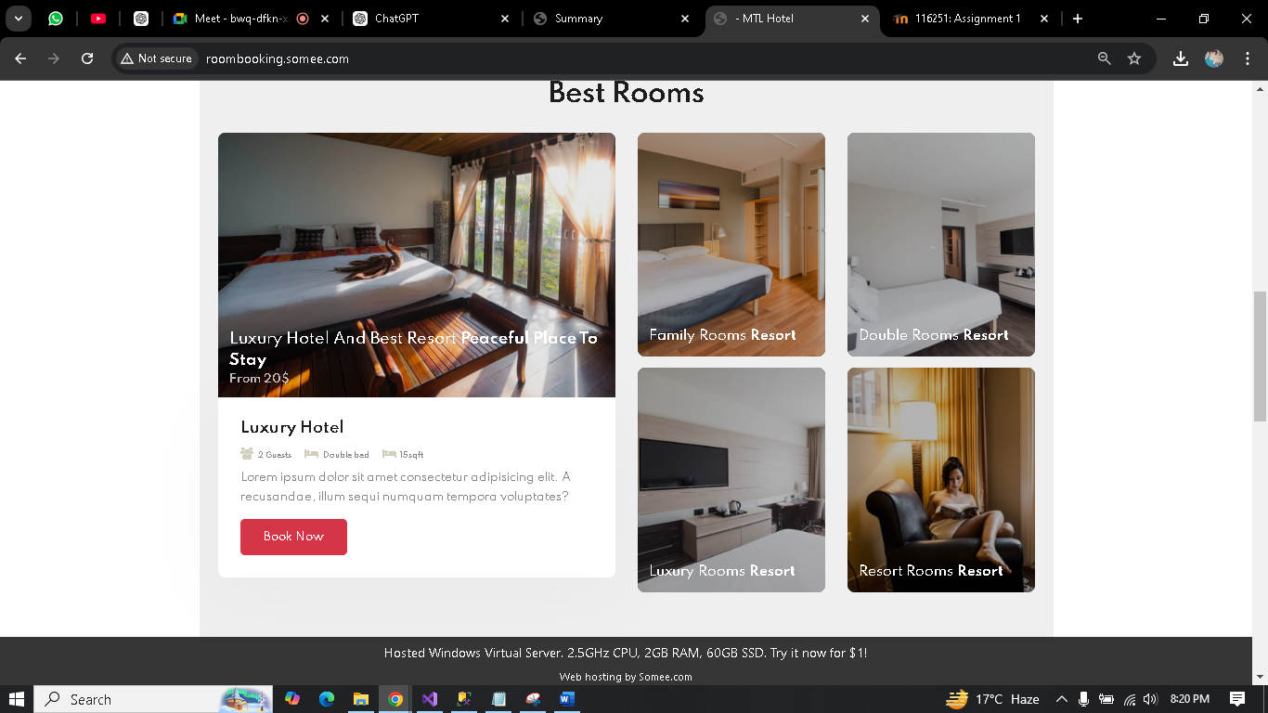
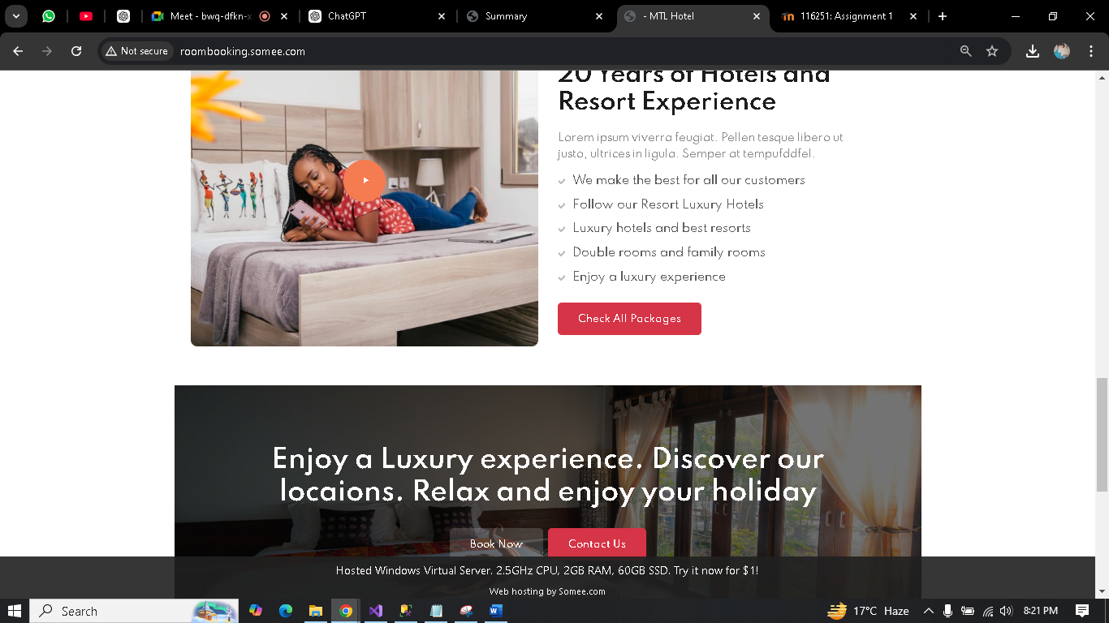

About page

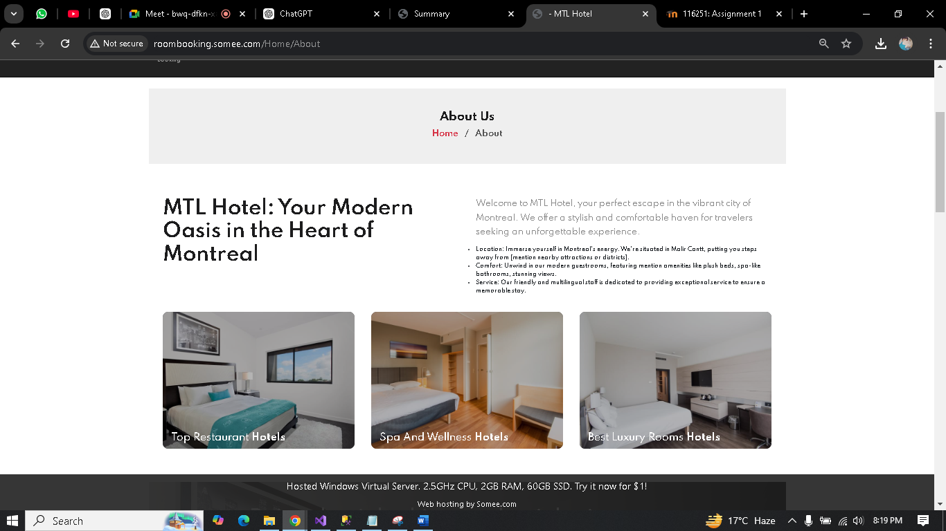

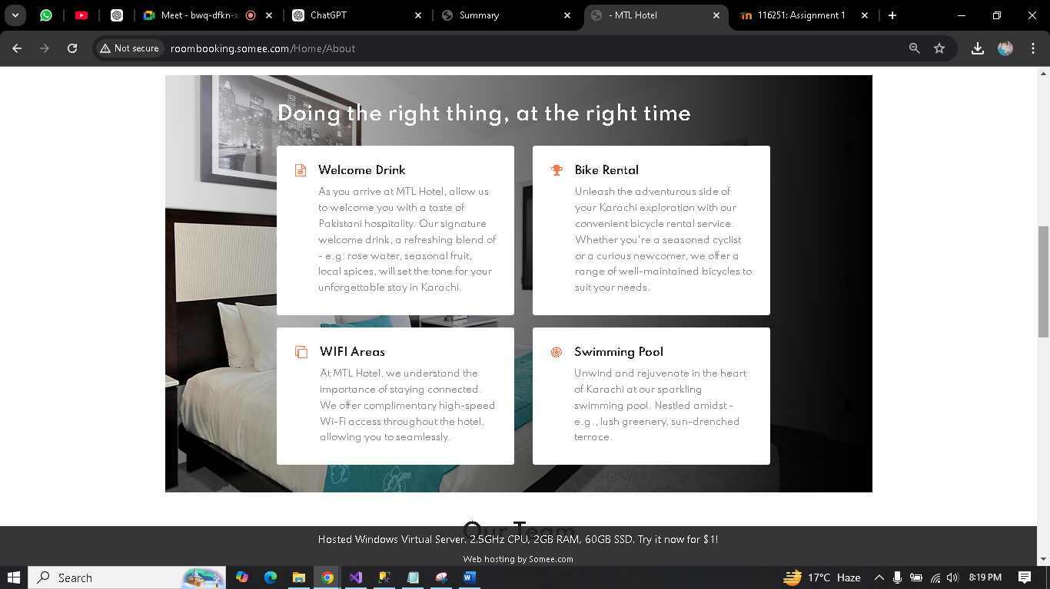
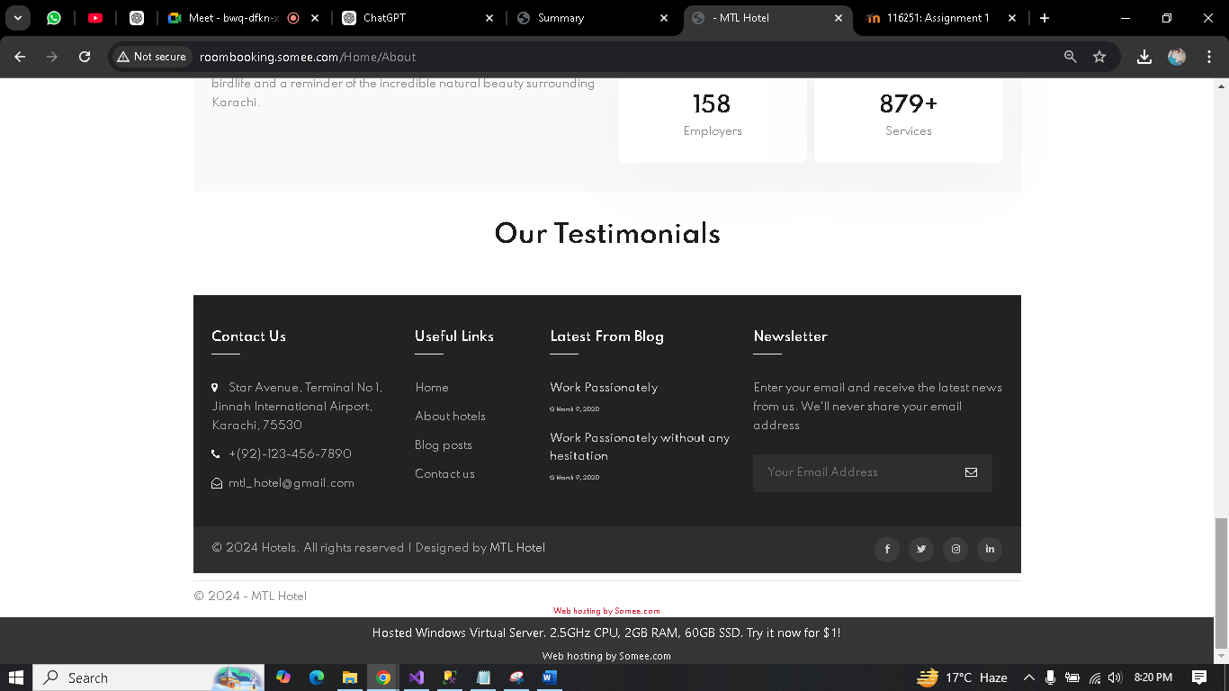

Contact Page

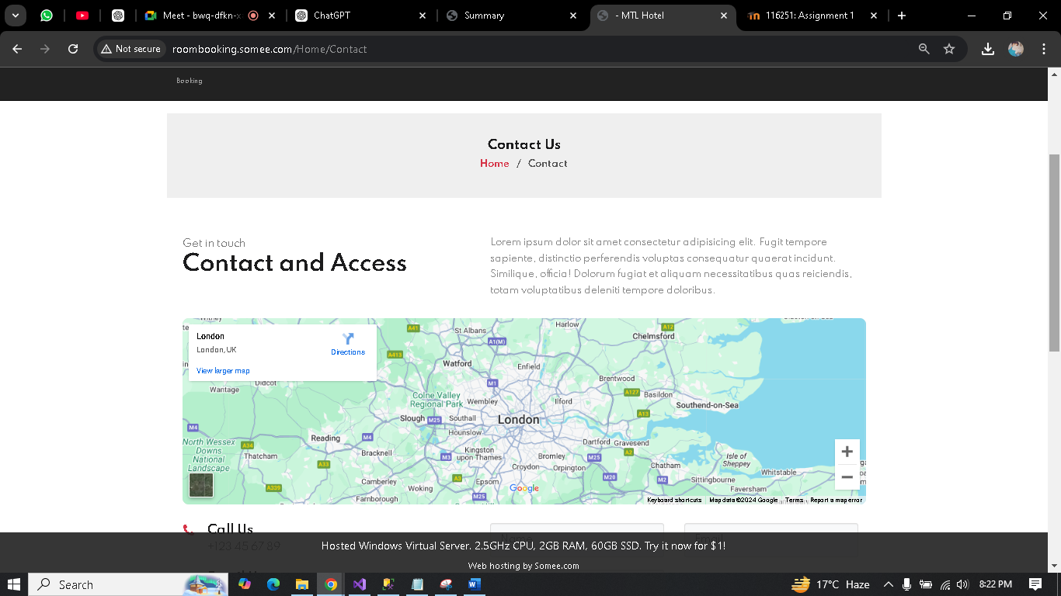
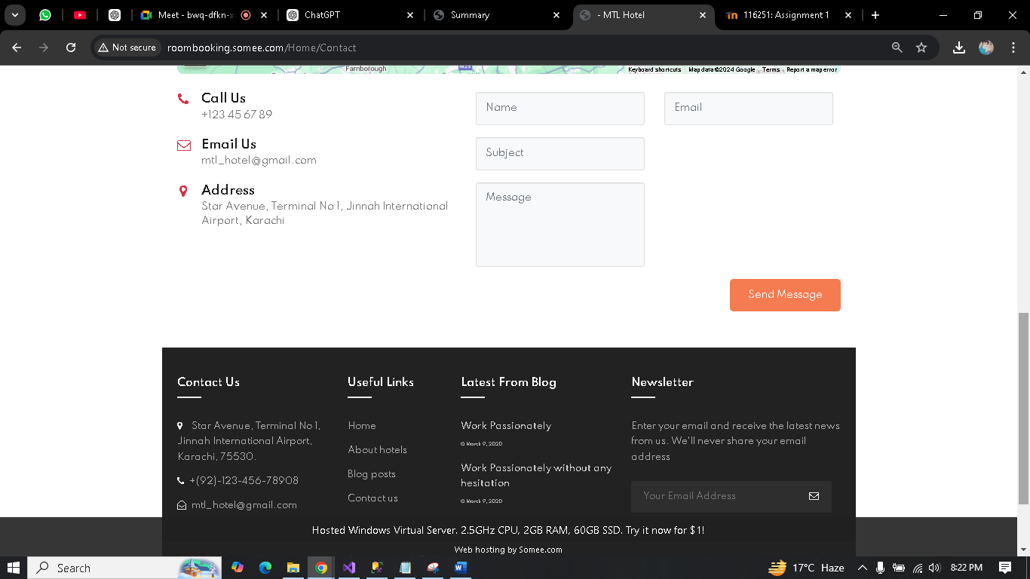

Services page
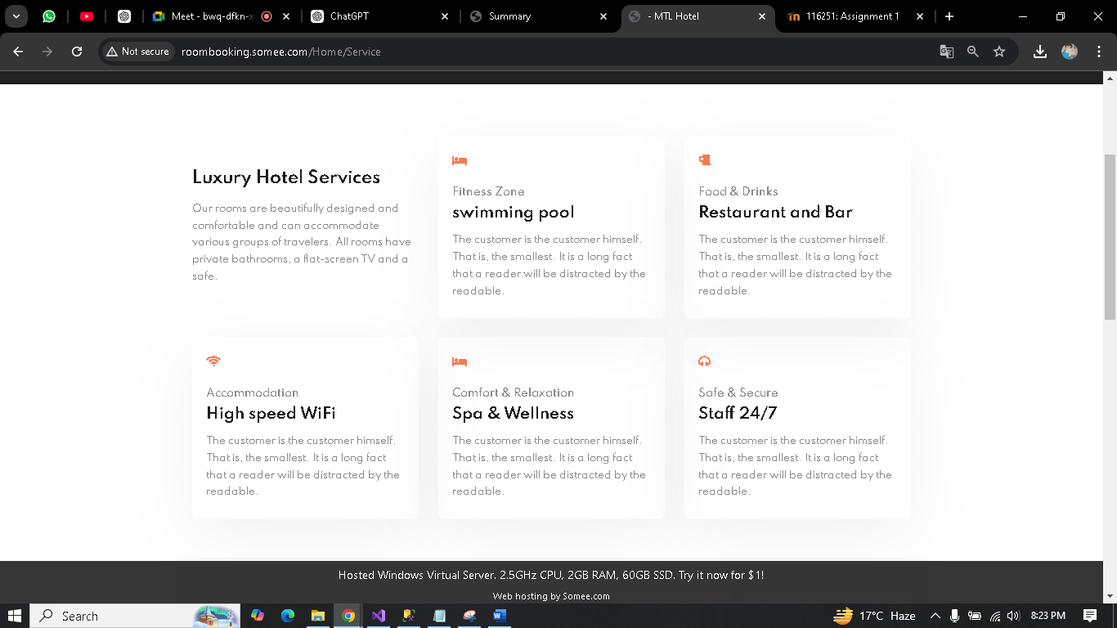

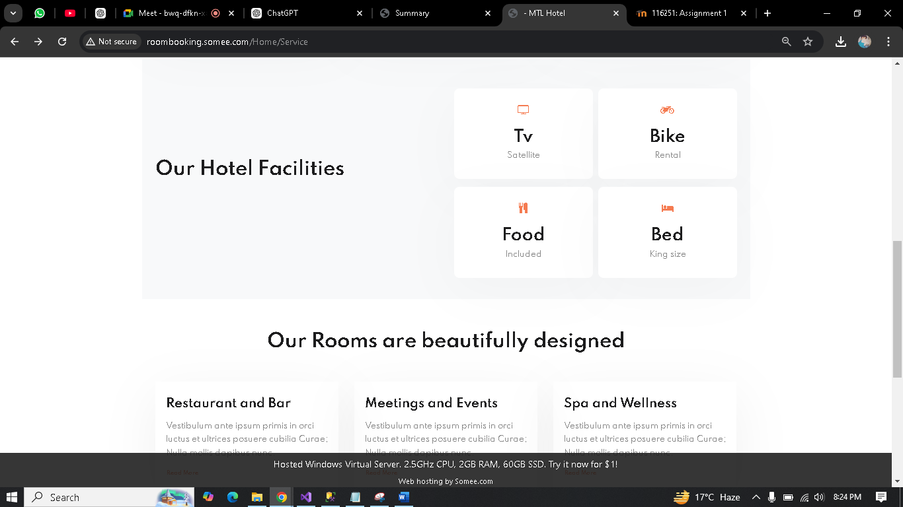

Room
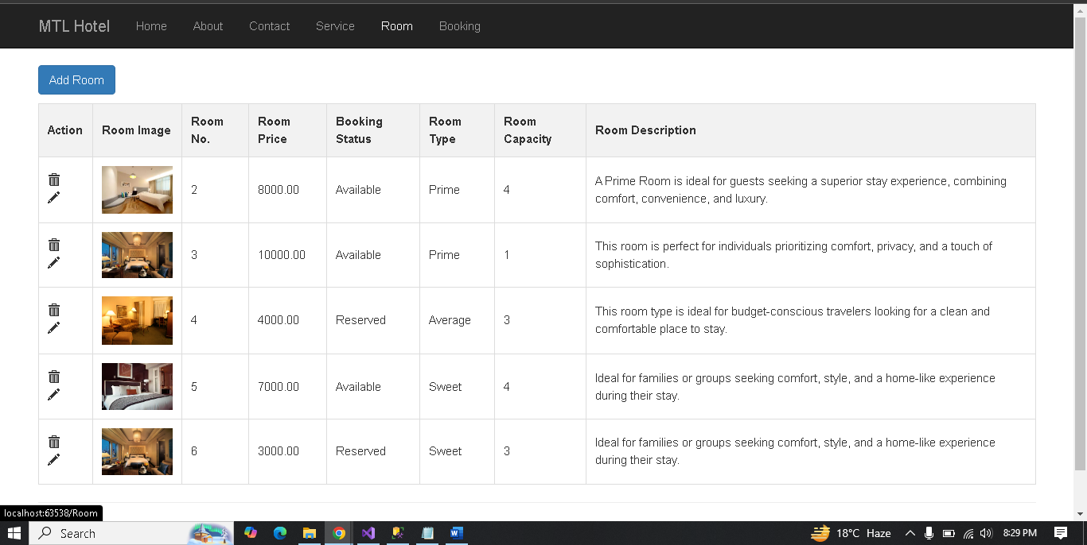
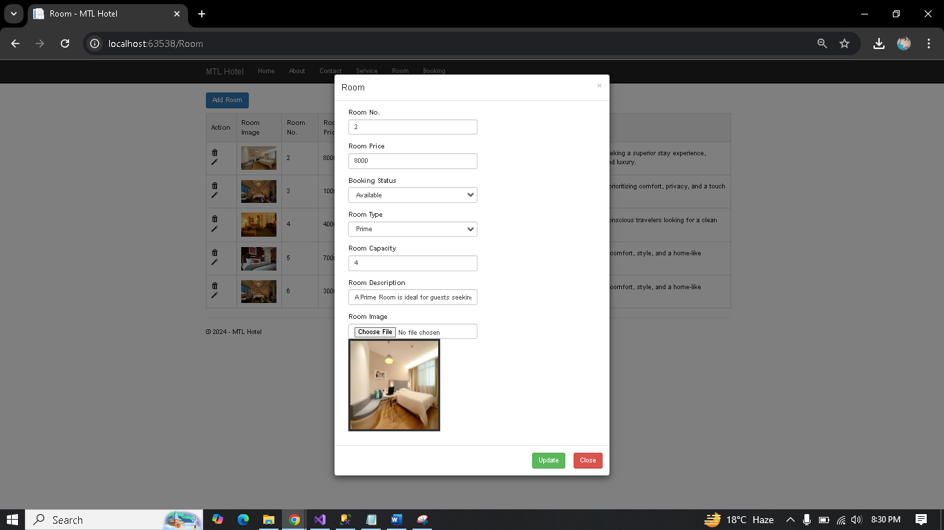
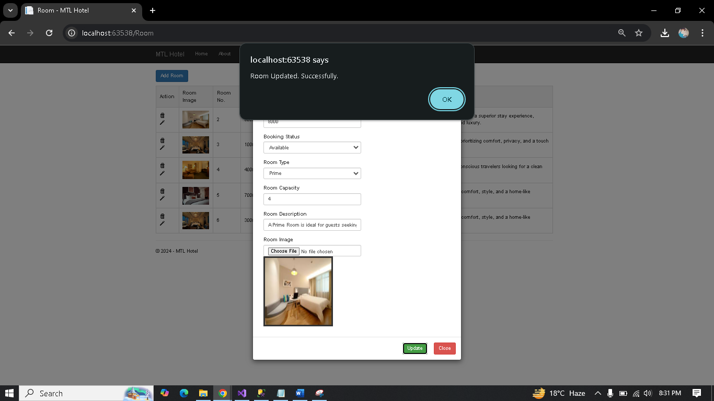
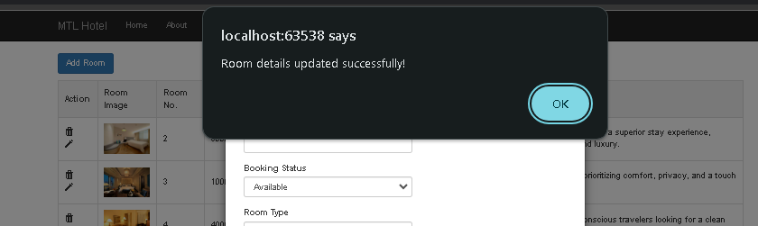

Booking
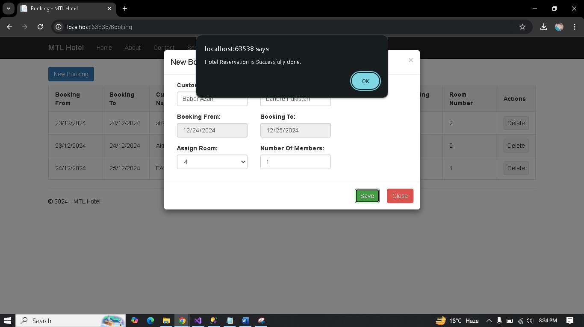
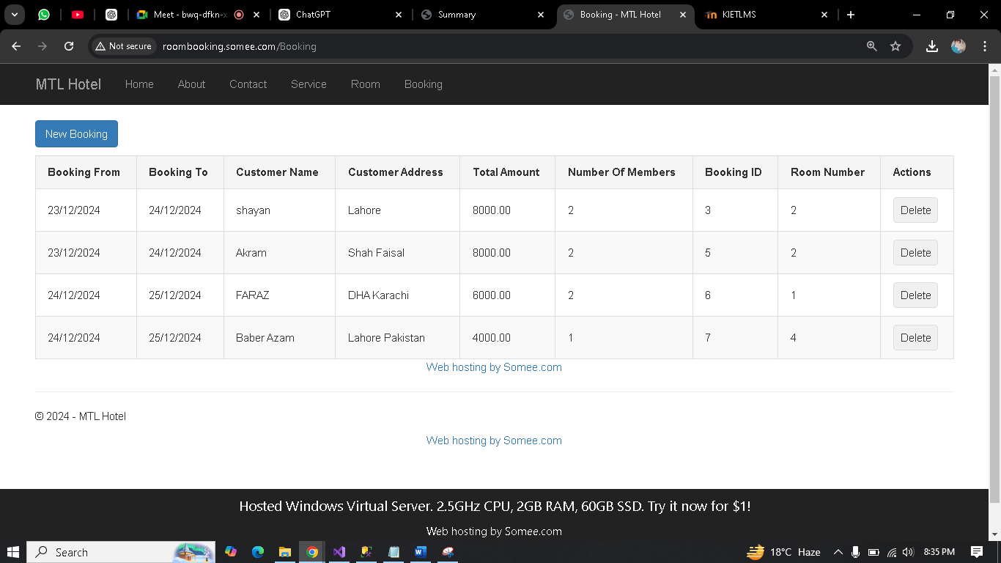

Deleting reservation
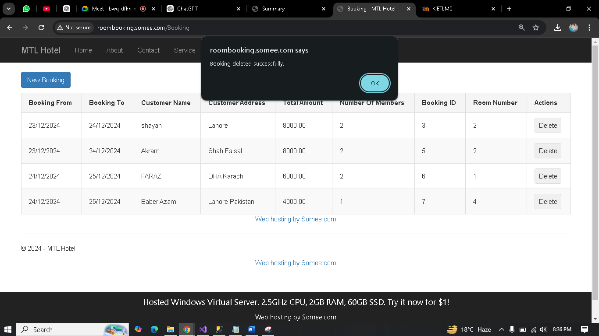
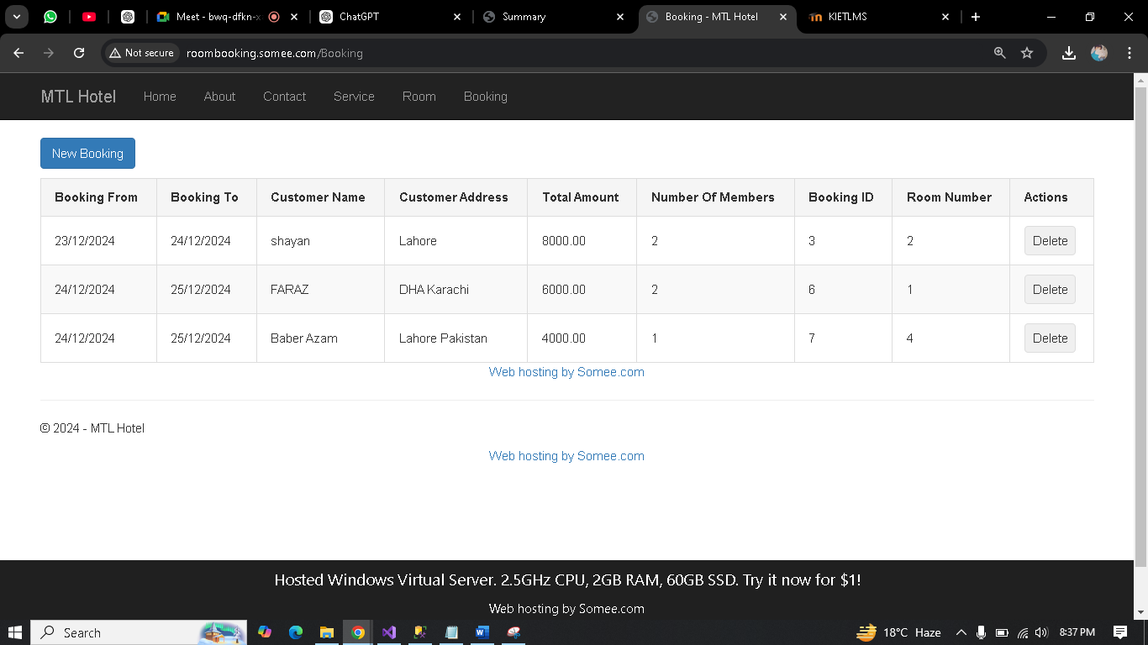

SQL query script
USE [MTLDB]
GO
/****** Object: Schema [hotel] Script Date: 12/24/2024 7:20:30 PM ******/
CREATE SCHEMA [hotel]
GO
/****** Object: Schema [Master] Script Date: 12/24/2024 7:20:30 PM ******/
CREATE SCHEMA [Master]
GO
/****** Object: Table [hotel].[Payments] Script Date: 12/24/2024 7:20:30 PM ******/
SET ANSI_NULLS ON
GO
SET QUOTED_IDENTIFIER ON
GO
CREATE TABLE [hotel].[Payments](
[PaymentId] [int] IDENTITY(1,1) NOT NULL,
[BookingId] [int] NOT NULL,
[PaymentTypeId] [int] NOT NULL,
[PaymentAmount] [decimal](18, 2) NOT NULL,
[IsActive] [bit] NOT NULL,
CONSTRAINT [PK_Payments] PRIMARY KEY CLUSTERED
(
[PaymentId] ASC
)WITH (PAD_INDEX = OFF, STATISTICS_NORECOMPUTE = OFF, IGNORE_DUP_KEY = OFF, ALLOW_ROW_LOCKS = ON, ALLOW_PAGE_LOCKS = ON, OPTIMIZE_FOR_SEQUENTIAL_KEY = OFF) ON [PRIMARY]
) ON [PRIMARY]
GO
/****** Object: Table [hotel].[RoomBookings] Script Date: 12/24/2024 7:20:30 PM ******/
SET ANSI_NULLS ON
GO
SET QUOTED_IDENTIFIER ON
GO
CREATE TABLE [hotel].[RoomBookings](
[BookingId] [int] IDENTITY(1,1) NOT NULL,
[CustomerName] [varchar](150) NOT NULL,
[CustomerAddress] [nvarchar](550) NOT NULL,
[BookingFrom] [date] NOT NULL,
[BookingTo] [date] NOT NULL,
[AssignRoomId] [int] NOT NULL,
[NoOfMembers] [int] NOT NULL,
[TotalAmount] [decimal](18, 2) NOT NULL,
CONSTRAINT [PK_RoomBookings] PRIMARY KEY CLUSTERED
(
[BookingId] ASC
)WITH (PAD_INDEX = OFF, STATISTICS_NORECOMPUTE = OFF, IGNORE_DUP_KEY = OFF, ALLOW_ROW_LOCKS = ON, ALLOW_PAGE_LOCKS = ON, OPTIMIZE_FOR_SEQUENTIAL_KEY = OFF) ON [PRIMARY]
) ON [PRIMARY]
GO
/****** Object: Table [hotel].[Rooms] Script Date: 12/24/2024 7:20:30 PM ******/
SET ANSI_NULLS ON
GO
SET QUOTED_IDENTIFIER ON
GO
CREATE TABLE [hotel].[Rooms](
[RoomId] [int] IDENTITY(1,1) NOT NULL,
[RoomNumber] [int] NOT NULL,
[RoomImage] [nvarchar](550) NOT NULL,
[RoomPrice] [decimal](18, 2) NOT NULL,
[BookingStatusId] [int] NOT NULL,
[RoomTypeId] [int] NOT NULL,
[RoomCapacity] [int] NOT NULL,
[RoomDescription] [nvarchar](550) NULL,
[IsActive] [bit] NULL,
CONSTRAINT [PK_Rooms] PRIMARY KEY CLUSTERED
(
[RoomId] ASC
)WITH (PAD_INDEX = OFF, STATISTICS_NORECOMPUTE = OFF, IGNORE_DUP_KEY = OFF, ALLOW_ROW_LOCKS = ON, ALLOW_PAGE_LOCKS = ON, OPTIMIZE_FOR_SEQUENTIAL_KEY = OFF) ON [PRIMARY]
) ON [PRIMARY]
GO
/****** Object: Table [Master].[BookingStatus] Script Date: 12/24/2024 7:20:30 PM ******/
SET ANSI_NULLS ON
GO
SET QUOTED_IDENTIFIER ON
GO
CREATE TABLE [Master].[BookingStatus](
[BookingStatusId] [int] IDENTITY(1,1) NOT NULL,
[BookingStatus] [varchar](50) NOT NULL,
CONSTRAINT [PK_BookingStatus] PRIMARY KEY CLUSTERED
(
[BookingStatusId] ASC
)WITH (PAD_INDEX = OFF, STATISTICS_NORECOMPUTE = OFF, IGNORE_DUP_KEY = OFF, ALLOW_ROW_LOCKS = ON, ALLOW_PAGE_LOCKS = ON, OPTIMIZE_FOR_SEQUENTIAL_KEY = OFF) ON [PRIMARY]
) ON [PRIMARY]
GO
/****** Object: Table [Master].[PaymentTypes] Script Date: 12/24/2024 7:20:30 PM ******/
SET ANSI_NULLS ON
GO
SET QUOTED_IDENTIFIER ON
GO
CREATE TABLE [Master].[PaymentTypes](
[PaymentTypeId] [int] IDENTITY(1,1) NOT NULL,
[PaymentType] [varchar](50) NOT NULL,
CONSTRAINT [PK_PaymentTypes] PRIMARY KEY CLUSTERED
(
[PaymentTypeId] ASC
)WITH (PAD_INDEX = OFF, STATISTICS_NORECOMPUTE = OFF, IGNORE_DUP_KEY = OFF, ALLOW_ROW_LOCKS = ON, ALLOW_PAGE_LOCKS = ON, OPTIMIZE_FOR_SEQUENTIAL_KEY = OFF) ON [PRIMARY]
) ON [PRIMARY]
GO
/****** Object: Table [Master].[RoomTypes] Script Date: 12/24/2024 7:20:30 PM ******/
SET ANSI_NULLS ON
GO
SET QUOTED_IDENTIFIER ON
GO
CREATE TABLE [Master].[RoomTypes](
[RoomTypeId] [int] IDENTITY(1,1) NOT NULL,
[RoomTypeName] [varchar](50) NOT NULL,
CONSTRAINT [PK_RoomTypes] PRIMARY KEY CLUSTERED
(
[RoomTypeId] ASC
)WITH (PAD_INDEX = OFF, STATISTICS_NORECOMPUTE = OFF, IGNORE_DUP_KEY = OFF, ALLOW_ROW_LOCKS = ON, ALLOW_PAGE_LOCKS = ON, OPTIMIZE_FOR_SEQUENTIAL_KEY = OFF) ON [PRIMARY]
) ON [PRIMARY]
GO
SET IDENTITY_INSERT [hotel].[RoomBookings] ON
GO
INSERT [hotel].[RoomBookings] ([BookingId], [CustomerName], [CustomerAddress], [BookingFrom], [BookingTo], [AssignRoomId], [NoOfMembers], [TotalAmount]) VALUES (1, N'Shayan', N'Malir karachi', CAST(N'2024-12-23' AS Date), CAST(N'2024-12-24' AS Date), 1, 2, CAST(6000.00 AS Decimal(18, 2)))
GO
INSERT [hotel].[RoomBookings] ([BookingId], [CustomerName], [CustomerAddress], [BookingFrom], [BookingTo], [AssignRoomId], [NoOfMembers], [TotalAmount]) VALUES (3, N'shayan', N'Lahore', CAST(N'2024-12-23' AS Date), CAST(N'2024-12-24' AS Date), 10, 2, CAST(8000.00 AS Decimal(18, 2)))
GO
INSERT [hotel].[RoomBookings] ([BookingId], [CustomerName], [CustomerAddress], [BookingFrom], [BookingTo], [AssignRoomId], [NoOfMembers], [TotalAmount]) VALUES (5, N'Akram', N'Shah Faisal', CAST(N'2024-12-23' AS Date), CAST(N'2024-12-24' AS Date), 10, 2, CAST(8000.00 AS Decimal(18, 2)))
GO
SET IDENTITY_INSERT [hotel].[RoomBookings] OFF
GO
SET IDENTITY_INSERT [hotel].[Rooms] ON
GO
INSERT [hotel].[Rooms] ([RoomId], [RoomNumber], [RoomImage], [RoomPrice], [BookingStatusId], [RoomTypeId], [RoomCapacity], [RoomDescription], [IsActive]) VALUES (6, 1, N'3e3126f6-f54b-4fdd-9cec-9c568e3a5ae7.jpg', CAST(6000.00 AS Decimal(18, 2)), 2, 1, 2, N'Ideal for travelers seeking comfort, privacy and a premium experience.', 1)
GO
INSERT [hotel].[Rooms] ([RoomId], [RoomNumber], [RoomImage], [RoomPrice], [BookingStatusId], [RoomTypeId], [RoomCapacity], [RoomDescription], [IsActive]) VALUES (7, 2, N'40b3691d-7041-4d22-8b7a-2b1d23a3a56c.jpg', CAST(8000.00 AS Decimal(18, 2)), 1, 2, 4, N'A Prime Room is ideal for guests seeking a superior stay experience, combining comfort, convenience, and luxury.', 1)
GO
INSERT [hotel].[Rooms] ([RoomId], [RoomNumber], [RoomImage], [RoomPrice], [BookingStatusId], [RoomTypeId], [RoomCapacity], [RoomDescription], [IsActive]) VALUES (10, 2, N'', CAST(8000.00 AS Decimal(18, 2)), 3, 2, 4, N'A Prime Room is ideal for guests seeking a superior stay experience, combining comfort, convenience, and luxury.', 0)
GO
INSERT [hotel].[Rooms] ([RoomId], [RoomNumber], [RoomImage], [RoomPrice], [BookingStatusId], [RoomTypeId], [RoomCapacity], [RoomDescription], [IsActive]) VALUES (12, 3, N'2ec0af22-947a-413d-8171-3e17ef77cf8f.jpg', CAST(10000.00 AS Decimal(18, 2)), 1, 2, 1, N'This room is perfect for individuals prioritizing comfort, privacy, and a touch of sophistication.', 1)
GO
INSERT [hotel].[Rooms] ([RoomId], [RoomNumber], [RoomImage], [RoomPrice], [BookingStatusId], [RoomTypeId], [RoomCapacity], [RoomDescription], [IsActive]) VALUES (21, 3, N'', CAST(10000.00 AS Decimal(18, 2)), 3, 3, 1, N'This room is perfect for individuals prioritizing comfort, privacy, and a touch of sophistication.', 1)
GO
INSERT [hotel].[Rooms] ([RoomId], [RoomNumber], [RoomImage], [RoomPrice], [BookingStatusId], [RoomTypeId], [RoomCapacity], [RoomDescription], [IsActive]) VALUES (22, 4, N'4be7e47b-f48a-4581-ad7b-16fe146e0754.jpg', CAST(4000.00 AS Decimal(18, 2)), 2, 3, 3, N'This room type is ideal for budget-conscious travelers looking for a clean and comfortable place to stay.', 1)
GO
INSERT [hotel].[Rooms] ([RoomId], [RoomNumber], [RoomImage], [RoomPrice], [BookingStatusId], [RoomTypeId], [RoomCapacity], [RoomDescription], [IsActive]) VALUES (23, 5, N'521d37b4-4f9e-4421-8ee0-a3a19444e8ef.jpg', CAST(7000.00 AS Decimal(18, 2)), 1, 1, 4, N'Ideal for families or groups seeking comfort, style, and a home-like experience during their stay.', 1)
GO
INSERT [hotel].[Rooms] ([RoomId], [RoomNumber], [RoomImage], [RoomPrice], [BookingStatusId], [RoomTypeId], [RoomCapacity], [RoomDescription], [IsActive]) VALUES (24, 6, N'af70b82f-046a-496c-889c-b5e6e8c19adf.jpg', CAST(3000.00 AS Decimal(18, 2)), 2, 1, 3, N'Ideal for families or groups seeking comfort, style, and a home-like experience during their stay.', 1)
GO
SET IDENTITY_INSERT [hotel].[Rooms] OFF
GO
SET IDENTITY_INSERT [Master].[BookingStatus] ON
GO
INSERT [Master].[BookingStatus] ([BookingStatusId], [BookingStatus]) VALUES (1, N'Available')
GO
INSERT [Master].[BookingStatus] ([BookingStatusId], [BookingStatus]) VALUES (2, N'Reserved')
GO
SET IDENTITY_INSERT [Master].[BookingStatus] OFF
GO
SET IDENTITY_INSERT [Master].[PaymentTypes] ON
GO
INSERT [Master].[PaymentTypes] ([PaymentTypeId], [PaymentType]) VALUES (1, N'Cash')
GO
INSERT [Master].[PaymentTypes] ([PaymentTypeId], [PaymentType]) VALUES (2, N'Card Check')
GO
SET IDENTITY_INSERT [Master].[PaymentTypes] OFF
GO
SET IDENTITY_INSERT [Master].[RoomTypes] ON
GO
INSERT [Master].[RoomTypes] ([RoomTypeId], [RoomTypeName]) VALUES (1, N'Sweet')
GO
INSERT [Master].[RoomTypes] ([RoomTypeId], [RoomTypeName]) VALUES (2, N'Prime')
GO
INSERT [Master].[RoomTypes] ([RoomTypeId], [RoomTypeName]) VALUES (3, N'Average')
GO
SET IDENTITY_INSERT [Master].[RoomTypes] OFF
GO
ALTER TABLE [hotel].[Payments] ADD CONSTRAINT [DF_Payments_IsActive] DEFAULT ((1)) FOR [IsActive]
GO
ALTER TABLE [hotel].[Rooms] ADD CONSTRAINT [DF_Rooms_IsActive] DEFAULT ((1)) FOR [IsActive]
GO
EXEC sys.sp_addextendedproperty @name=N'MS_Description', @value=N'Occupied
Available
Reserved
' , @level0type=N'SCHEMA',@level0name=N'hotel', @level1type=N'TABLE',@level1name=N'Rooms', @level2type=N'COLUMN',@level2name=N'RoomTypeId'
GO

CONCLUSION
The conclusion summarizes the key findings of the Object-Oriented Analysis and Design (OOAD) process, emphasizing the successful modeling and design of the Hotel Management System. It discusses the potential impact of the proposed system on hotel efficiency, resource utilization, and overall guest satisfaction.
The implementation of this system ensures smoother operations, better management of room bookings, enhanced customer service, and optimized allocation of staff and resources. With the adoption of such a system, hotels can improve operational effectiveness, streamline workflows, and provide a seamless experience for guests, making it a valuable asset for the hospitality industry.

